- Project name:
«Accessible environment-a world of equal opportunities»
- Project implementation period:
2022-2023
- The applicant, the proposed project:
«State educational institution "Kletsky nursery-garden № 2»
- Project objective:
expanding the range of material and technical conditions to provide children with disabilities with equal access to education and quality education
- Tasks planned for implementation within the framework of the project:
- to organize unhindered access to pre-school education through the reconstruction of the entrance ramp;
- to provide a barrier-free environment throughout the path of movement of children inside the building through the arrangement of a crawler lift, enclosing the railings on the stairwell, corridors;
- to provide access for children to receive recreational activities in the pool by installing a stationary lift;
- to carry out reconstruction of sanitary and hygienic premises;
-to improve the adaptive environment by equipping specialized furniture, modern technical means of training and education, modular structures of the game and developing elements.
- Task force:
children of pre-school age with disabilities of the city of Kletsk and the discrict.
Brief description of project activities:
In the state educational institution "Kletsky nursery-garden № 2" will be held:
- reconstruction of the entrance ramp taking into account the technical regulations on the creation of a barrier-free environment for children with disabilities;
- installation of a lift for lifting and lowering disabled children; - arrangement of the protecting devices, the railing on a flight of stairs, corridors;
- reconstruction of sanitary facilities;
- providing the environment with means of transportation, specialized furniture and modular structures;
- saturation of the educational environment with modern technical means of training and education.
To implement the project, it is necessary to purchase the following items:
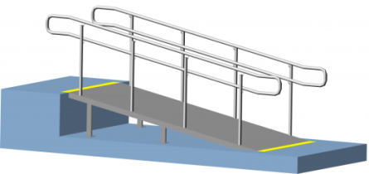
Entrance ramp-930$
The design, providing a vertical path of movement and consisting of inclined planes (stepless marches) and horizontal platforms.

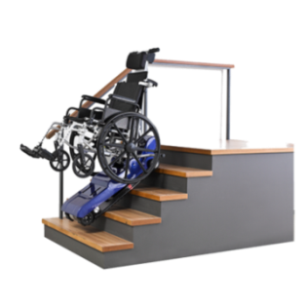
Tracked stair lift

"Bars-UGP-130" (stepladder)- 3456$

The lifting means by means of which move children with limited motor abilities on ladder marches in the rooms which are not equipped with elevators and ramps. Management is made by the person accompanying the child in a wheelchair.

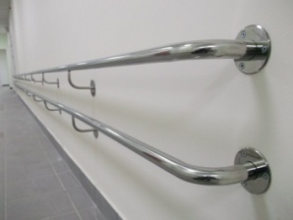
Double handrails on the route 1 and 2 floors-1674$
The shape and size of the handrails should provide maximum convenience for their grip with a hand brush.

Stationary lift for swimming pool for children with disabilities IPB-170G-3023$
Designed for moving, lifting and lowering the child in the pool.

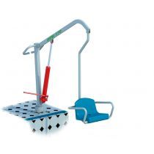
Reconstruction of 4 sanitary-hygienic premises-1302$
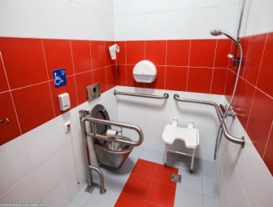
Intended for people with disabilities who use wheelchairs, assistive devices or fixtures, should be installed handrails, bars, hanging trapezes or other equipment, and showers for the disabled be equipped with stationary or folding seat.

The buggy-2 PCs. - 502$
A means for the movement of a child with disabilities, a way to partially return to normal life.
.

Walkers - 2 PCs.-232$
Designed for walking in coordination disorders or simply to maintain the musculoskeletal system of the child.

Table on wheels - 2 PCs.-1376$

Designed for food intake and the organization of remedial classes. Can be used in both sitting and standing position. For ease of movement, the table is equipped with wheels with Parking brakes. To either side of the table you can attach a box for personal accessories of the child.
Functional orthopedic chair-chair on wheels for children cerebral palsy - 2 PCs.-865$
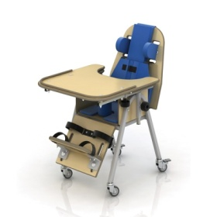
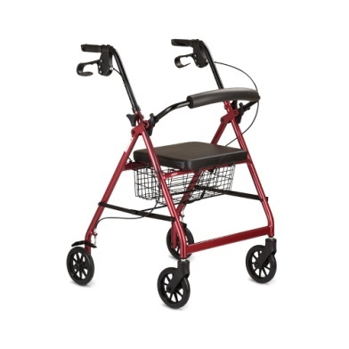
It allows you to train the process of keeping the head in an upright position, to form the correct posture, and also provides suppression of pathological reflexes. The included platform on wheels is easy to mount and has a Parking brake .

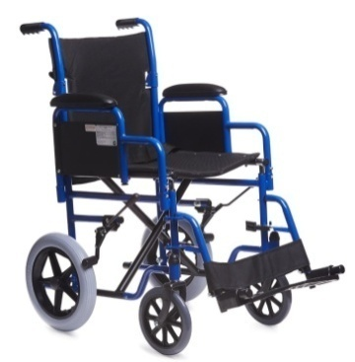
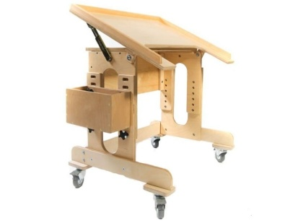
Interactive sandbox - 4642$
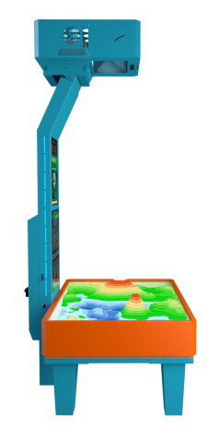
It promotes the development of memory, tactile sensitivity, visual thinking, fine motor skills of hands, which directly affects the development of speech and thinking in General. Classes in the interactive sandbox help the child to develop comprehensively and contribute to the normalization of the psycho-emotional state of children.

INTERACTIVE WHITEBOARD

TECHNOBOARD 91-773$
Allows ten users to work on it at the same time, who can write, draw and move objects with a finger, a pointer, a marker, a pencil or any other object.

Children's play complex for children with disabilities -4336$
It is a modular construction of game and developing elements. Performs the following functions: creates conditions that ensure the physical development of the child, developing coordination of movements, overcoming the fear of heights, agility and courage, a sense of collectivism in mass games.
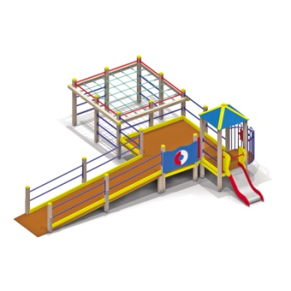
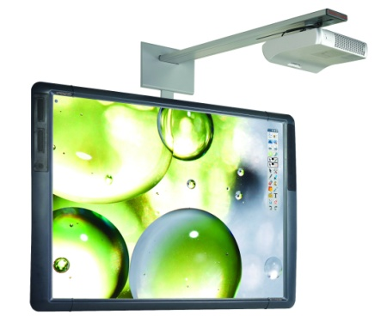
Expected result:
-provision of equal educational opportunities for children with disabilities and healthy children;
- creation of a modern educational environment, comfortable for children with disabilities;
- social adaptation of children in the educational space of educational institutions;
- improving the quality of correctional and pedagogical assistance to children;
- preservation and strengthening of health, correction of deficiencies in the physical and mental health of children;
- improving the social status of pre-school institutions, the formation of a positive image.

- Total funding (in us dollars)
Source of financing | Amount of financing  (in us dollars)
Donor funds | 23111
Co-financing | 2300
- Project location (region/ district, city):
Minsk region, Kletsk
- Contact person:
- Gargun Natalia Pavlovna, head of the state educational institution "Kletsky nursery-garden № 2»
80179363621, 80179369059 , sad2@kletsk-asveta.gov.by

